Program 1
//Program to find if number is a prime number or not via While loop.

#include<stdio.h>
int main(){
int i=0,num,ctr=0;
printf("Enter a number:\n");
scanf("%d",&num);
if(num==1)
printf("\n1 is not a prime number\n");

while(i<=(num/2)){
if(num%i==0)
ctr++;

if(ctr>=2){
printf("\n%d is not a prime number\n",num);
break;
}

i++;
}
if(ctr<2 && num!=1)
printf("\n%d is a prime number\n",num);
}
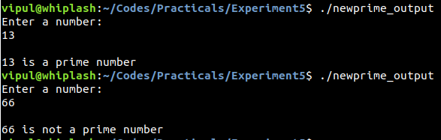
Program 2
// Program to reverse a number via For loop.

#include<stdio.h>
int main(){
int num, rev=0;
printf("Enter number:\n");
scanf("%d",&num);
for(;num>0;){
rev=rev*10+num%10;
num/=10;
}
printf("\n%d is the reversed number\n",rev);
}

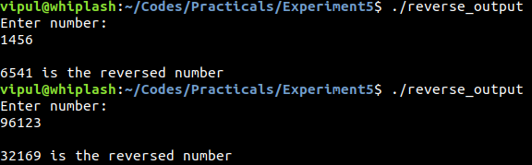
Program 3
// Program to find sum of digits via While loop

#include<stdio.h>
int main(){
int num,sum=0;
printf("Enter a number:\n");
scanf("%d",&num);
while(num>0){
sum+=num%10;
num/=10;
}
printf("\nThe sum of digits is %d\n",sum);
}

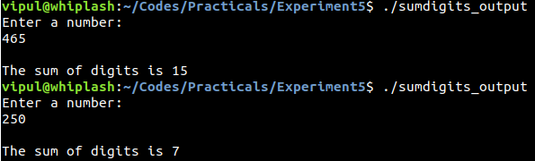
Program 4
// Program to print multiplication table via For loop

#include<stdio.h>
int main(){
int num;
printf("Enter number whose multiplication table you wish to see:\n");
scanf("%d",&num);
printf(“\n”);
for(int i=0;i<=10;i++)
printf("%d * %d = %d\n",num,i,num*i);

}

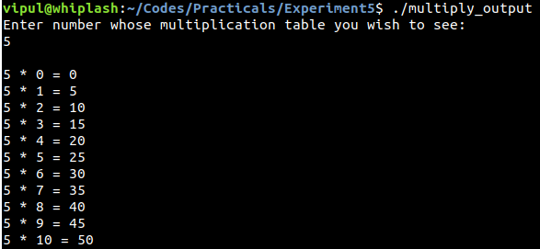
Program 5
// Program to count number of odd and even numbers between 1-100 using for loop.

#include<stdio.h>
int main()
{
int even=0,odd;
for(int i=1;i<=100;i++){
if(i%2==0)
even++;
}
odd=100-even;
printf("Number of Odd Numbers between 1-100 are %d\nNumber of Even Numbers between 1-100 are %d\n",odd,even);

}

Program 6
// Program to find factorial of a number using For loop.

#include<stdio.h>
int main(){
int num,fact=1;
printf("Enter number whose factorial you wish to find:\n");
scanf("%d",&num);
for(int i=1;i<=num;i++)
fact*=i;
printf("\nThe Factorial of %d is %d\n",num,fact);
}

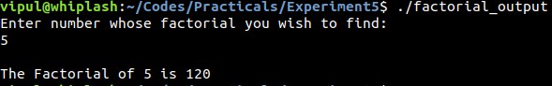
Program 7
//Program to find fibonacci series using For loop.

#include<stdio.h>
int main()
{
int n,f=0,s=1,sum=0;
printf("Enter number of terms:\n");
scanf("%d",&n);
printf("\n");
for(int i=1;i<=n;i++){
printf("%d ",f);
sum=f+s;
f=s;
s=sum;
}
printf("\n");
}

